|  |
| --- |
| Specific Ethical Protocol  for Scientific Research at the Faculty of Psychology and Educational Sciences of Ghent University |
| Version of March 18, 2015  Ethical Committee, Faculty of Psychology and Educational Sciences, Ghent University, Henri Dunantlaan 2, 9000 Ghent |

REQUEST TO THE ETHICAL COMMITTEE FOR ADVICE CONCERNING THE FOLLOWING RESEARCH PROPOSAL:

# TITle of the research project:

Empirical evaluation of the moderating impact of motion on the uncanny valley phenomenon: A pre-registered replication of Piwek, McKay, and Pollick (2014) *Cognition*.

# Name of the researcher(S):

Sean Hughes

PHONE NUMBER: 09 264 86 49

SUPERVISOR (IF ANY):

DEPARTMENT: Experimental Clinical and Health Psychology

# IS THERE A FINANCIAL SPONSOR FOR THIS PROJECT?

This project is sponsored by the Department of Defense (USA) through an award to the Center for Open Science.

# IS THE PROJECT PART OF ANY COOPERATION BEYOND THE FACULTY? IF SO, SPECIFY THE INSTITUTIONS INVOLVED.

This replication effort is part of the larger ‘Systematizing Confidence in Open Research and Evidence’ (SCORE) project; a large-scale, multi-site, registered replication effort being headed by the Centre for Open Science and the Department of Defense (USA). For more information on the SCORE project please see (<https://www.darpa.mil/program/systematizing-confidence-in-open-research-and-evidence>).

The specific project (i.e., a registered replication of Piwek et al., 2014) for which I am applying for ethical approval, will be carried out by myself (Sean Hughes) at Ghent University. The data and analyses will be publically hosted and made available for use by members of the Centre for Open Science, the Department of Defense (USA), and the public more generally.

# BRIEFLY SUMMARIZE THE RESEARCH PROJECT (AT MOST 200 TO 400 WORDS, ALSO UNDERSTANDABLE TO PEOPLE THAT ARE NOT ACQUAINTED WITH THE SUBJECT). EMPHASIZE WHAT ACTUALLY WILL HAPPEN DURING THE RESEARCH, FROM RECRUITING TO REPORTING (NOT THE THEORETICAL BACKGROUND).

The *uncanny valley hypothesis* states that the acceptability of an artificial character (such as a robot or artificial intelligence) will not increase linearly in relation to its likeness to human form. Instead, after an initial rise in acceptability there will be a pronounced decrease when the character is similar, but not identical to human form (Mori, 1970).

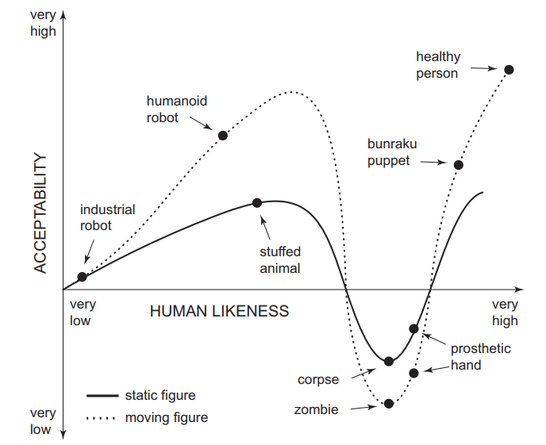

*Figure 1*. The uncanny valley effect.

Past work has claimed, but never directly tested, the idea that character movement accentuates this uncanny valley effect, such that moving characters are deemed to be less acceptable. Piwek, McKay, and Pollick (2014) set out to test this assumption. Using a number of full-body animated computer characters, which moved in different ways, they examined the effect of motion quality on the uncanny valley effect. They found that improving the motion quality (i.e., how realistically a character moved) actually decreased rather than increased the uncanny valley effect. Their results showed that although an uncanny valley effect did emerge for static characters, this effect was not increased by motion, as originally predicted by Mori (1970/2012).

In this project I will attempt to replicate Piwek et al.’s (2014) findings using an identical set of stimuli and by recording a similar set of responses. Participants will be recruited online (via the Prolific Academic recruiting platform: <https://prolific.ac/>). Prior to the study they will be informed that they will complete an experiment. The standard privacy and consent policy will be provided which they will read and agree to prior to initiating the experiment. This information will indicate that their data will be stored publically, used for research purposes, and stored separately from their demographic information. Participants will be informed that they can send the researchers an email if they have any questions about their rights and privacy and that they can terminate the study at any point (by contacting the researcher).

During the experiment itself they will encounter a series of videos of static or moving characters (see below) and be asked to provide self-reported ratings on those characters.

*Stimuli*. Stimuli consisted of seven 3D computer characters: a battle robot, toy robot, mannequin, skeleton, zombie, and low- and high-quality man (see Figure 2). All characters will be presented in the frontal orientation, facing the participant. To animate these characters, Piwek et al. (2014) used motion capture data of an individual knocking on a door with their right hand in a neutral manner. To manipulate the quality of these movements (from natural to increasingly artificial), the original authors created a set of increasingly distorted versions of the same knocking movements using MATLAB software (MathWorks). Once a set of motions was created, two-second video clips of the static and animated characters were generated using the Poser 6 software (Curious Labs, 2005; for examples see <https://osf.io/khcw8/?view_only=dd5875fc6af641f1b99729cb51981425>).

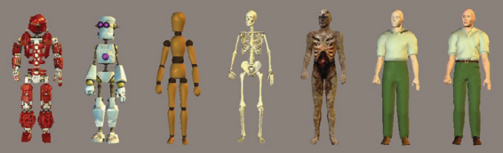

*Figure 2*. Stimuli that participants will encounter during the study.

*Procedure*. Participants will be divided up into two groups. Participants in the first (human likeness ratings) group will be shown a static image of a character for two seconds. After each image, they will rate the human likeness of that character on a 9-point Likert scale (1 = very non-humanlike to 9 = very humanlike). In the second (acceptability ratings) group, participants will be shown two-second-long videos of the complete set of animated characters performing a knocking action at every level of movement distortion. The second (acceptability ratings) group will also be shown a static image of each of the characters. These will be presented either at the start or end of the movie testing phase, with the presentation order being counterbalanced across participants.

After each presentation of the static or moving characters participants will rate the character’s acceptability on a 9-point Likert scale (1 = totally unacceptable, 9 = totally acceptable) by pressing the appropriate number (1–9) on the keyboard. Participants will be encouraged to go with their first impressions for their answer. Stimuli will be presented and responses collected via a html script created using the open-access Lab.js platform (<https://lab.js.org/>). Each participant in the acceptability ratings group will view six variations of the knocking action, at a natural plus four distorted levels of the movement, for each of seven characters.

# DOES THE RESEARCH PROJECT IMPLY ANY THREATS TO THE PARTICIPANTS’ HEALTH? HAVE YOU ALSO SUBMITTED A REQUEST TO THE MEDICAL ETHICAL COMMITTEE?

No. That said, reporting of unanticipated problems involving risks to subjects or others, suspensions, terminations, serious adverse events, and serious or continuing non-compliance shall be made in accordance with the Food and Drug Administration, the Department of Defense (DoD) and Ghent University’s regulations.

# ARE THE PARTICIPANTS HAVING ANY DIFFICULTIES KNOWN BEFOREHAND? IF SO, SPECIFY WHETHER THE RESEARCH PROJECT COULD INTERFERE WITH THESE DIFFICULTIES AND WHAT PRECAUTIONS YOU WOULD TAKE.

No

# IF THE PARTICIPANTS ARE ADULTS INCOMPETENT TO GIVE THEIR CONSENT, WHOM WILL BE ASKED PERMISSION TO?

Not applicable.

# IF THE PARTICIPANTS ARE MINORS, WHOM WILL BE ASKED PERMISSION TO? (ATTACH THE REQUEST FORM YOU WILL USE).

Not applicable.

# WILL DECEPTION BE USED DURING THE RESEARCH PROJECT? IF SO, DESCRIBE AND MOTIVATE.

No

# IN WHICH WAY WILL THE PARTICIPANTS BE INFORMED OF THE RESULTS OF THE RESEARCH PROJECT? WILL THERE BE A DEBRIEFING?

The experimental agenda will be shared with the participant after the experiment via the debriefing page. Here we will describe what the experiment was about and what we were hoping to find. Interested participants will also be able to find all results, the pre-registered protocol, final paper, and all other materials at the Open Science Framework URL for this project (<https://osf.io/khcw8/?view_only=dd5875fc6af641f1b99729cb51981425>). These will be made publically available as soon as each is component is completed.

# WILL STUDENTS BE CALLED IN TO ASSIST TO THE RECRUITMENT OF PARTICIPANTS, DATA COLLECTION OR DATA ANALYSIS?

No

# WHAT IS YOUR PLAN FOR DATA-MANAGEMENT, DURING AND AFTER THE PROJECT? PLEASE FOCUS ON ETHICALLY RELEVANT ASPECTS. HOW WILL YOU INFORM THE PARTICIPANTS ABOUT YOUR PLAN?

Data will be privately stored on our (Learning and Implicit Processes Lab) ACL share at Ghent University and made publically available via the Open Science Framework (OSF) repository (<https://osf.io/khcw8/?view_only=dd5875fc6af641f1b99729cb51981425>). During and after the publication process the data will be freely available to other researchers via the above link. Participants will be informed during the consent form that their data will be used for scientific purposes and shared with other scientists following the experiment. We will also indicate that their Prolific number will be recorded for payment related reasons, and that this information will be removed during data processing. We also ask participants for their explicit consent for the sharing of their data (see informed consent letter).

# IN THE CURRENT STATE OF THE RESEARCH PROJECT, DO YOU EXPECT OTHER DIFFICULTIES CONCERNING THE GENERAL ETHICAL PRINCIPLES AS WRITTEN DOWN IN THE GENERAL ETHICAL PROTOCOL? IF SO, DESCRIBE HOW AND MOTIVATE WHY THE RESEARCH PROJECT SHOULD DO SO

No

I DECLARE TO TAKE THE FULL RESPONSIBILITY OF THE PROJECT MENTIONED ABOVE AND CONFIRM THAT THE INFORMATION GIVEN IS CONSISTENT WITH THE FACTS AS KNOWN ON THIS VERY MOMENT. I ALSO DECLARE TO HAVE READ THE GENERAL ETHICAL PROTOCOL FOR SCIENTIFIC RESEARCH OF THE FACULTY OF PSYCHOLOGY AND EDUCATIONAL SCIENCES OF GHENT UNIVERSITY, AND TO SUBSCRIBE TO IT CONCERNING ANY ITEMS 6A TO 6H WHERE NO REMARKS HAVE BEEN MADE. SHOULD DURING THE COURSE OF THE RESEARCH PROJECT ETHICAL QUESTIONS ARISE THAT ARE NOT COVERED BY THIS REQUEST, I WILL CONTACT THE ETHICAL COMMITTEE ANEW.

THE RESEARCHER THE SUPERVISOR (AGREEMENT)

DATE: 19/10/2020 DATE:

NAME: Sean Hughes NAME:

SIGNATURE: SIGNATURE: